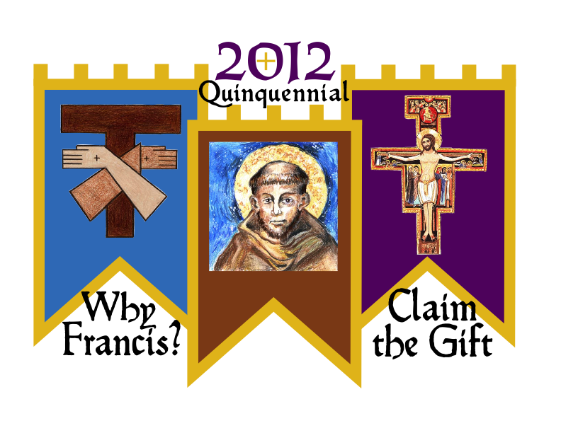
Quinquennial XVIII (2012)
Holiday Inn, Chicago North Shore
July 3 – 8, 2012

Tentative Schedule

Tuesday July 3rd
Arrivals and Registration throughout the day
5:00 Dinner
7:15 Welcome
7:30 Opening Liturgy: Bishop George J. Rassas, Auxiliary Bishop, Archdiocese of Chicago
9:00 Simple Social

Wednesday July 4th
7:30-8:30 Breakfast
8:45 Housekeeping announcements
9:00 Keynote: Why Francis? Claim the Gift! (Sr. Ilia Delio, OSF)
10:00 Mutual Invitation review (Jan Parker, SFO)
10:15 Q fraternities: Introductions, What are you hoping to experience at this Quenquennial?
11:30 Liturgy of the day (CNSA)
12:30 Lunch
2:00 Who are you, O Lord? —A Franciscan view of God (Sr. Ilia Delio, OSF)
3:00 Break
3:30 Q fraternities: prayer/study using mutual invitation. Discussion: Our View of God, Reflections on the talk.
3:30 CNSA session for Experienced Spiritual Assistants
4:45 Break
5:00 Evening Prayer
5:30 Dinner (picnic in Skokie Park)
7:00 Ongoing social time

Thursday July 5th
7:30-8:30 Breakfast
8:45 Housekeeping announcements
9:00 And What am I? The Franciscan understanding of the human person (Sr. Ilia Delio, OSF)
10:00 Break
10:15 Q fraternities: Meditation using mutual invitation. Discussion: Reflections on the talk;
Our view of ourselves, What is God’s view?
11:30 Liturgy of the day (CNSA)

12:30 Lunch
2:00 Deepening our relationship with God: tools for a more authentic spiritual life Ed Shirley, SFO
3:00 Break
3:30 CNSA session for New Spiritual Assistants (Part 1)
3:30 Q fraternities: Discussion: Reflections on the talk, What is God saying to you about your relationship with Him?
5:40 Evening Prayer
6:00 Dinner
7:00 CNSA session for New Spiritual Assistants (Part 2)
7:45 The Polish Highland Children’s Orchestra - Social

Friday, July 6th
7:30-8:30 Breakfast
8:45 Housekeeping announcements
9:00 Plenary: Who Are We? An overview of the Franciscan Family and the place of the SFO
and the rest of the Third Order. (Br. Bill Short, OFM)
10:00 Break
10:15 Q fraternities
11:30 Liturgy of the day (CNSA)
12:30 Lunch
2:00 The Rule of the SFO and Presence in the World Pat Brandwein-Ball, SFO
3:30 Q fraternities: Discussion, Reflections on the talk.
4:45 Break
5:40 Evening Prayer
6:00 Dinner
7:45 Chiesa Nuova, a Franciscan performing arts ministry Chicago - Social

Saturday, July 7th
7:30-8:30 Breakfast
8:45 Housekeeping announcements
9:00 Plenary: Claim the Gift! A process of discernment
10:15 Break
10:30 Adoration, time for private/personal prayer and discernment
11:45 Q fraternities — meditation on vocation, then discussion. What IS our gift, What is God
asking of us NOW in the 21st Century?
12:30 Lunch
2:00 Q fraternities—compose summary of discernments
3:00 Break
3:45 NAFRA ministers and delegates report and discuss the message from the Q fraternities; Everyone else, time for relaxation, recreation, or personal prayer, reflection.
5:30 Dinner
7:00 Summary of discussions—Minister (Dcn. Tom Bello, SFO)
7:30 Closing Liturgy

Sunday, July 8th
7:30-8:30 Breakfast
8:45 Morning Prayer and Closing Remarks

